**SRM USER’S GUIDE**



**SRM System**

**HIT Team**

Consulting

Sales

Staffing

Support

# SECTION 1: WINDOW APPLICATION

## Login

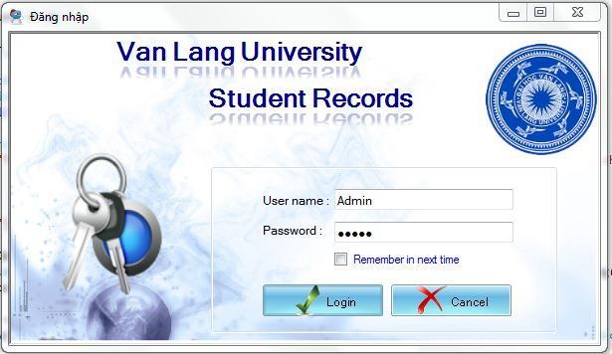

|  |  |
| --- | --- |
| Fields and Buttons | Rule |
| User name | Just Admin use “Admin” to login. With other account they must use the User ID to login |
| Password | Must have a minimum of one (1) characters, maximum of twenty (32) characters. |

## Import Student Records

To import an Excel file, you have to do the following steps:

Step 1: Choose Department that you want to import information

Step 2: Fill the Course

Step 3: Choose Browse button to select the Excel file and the click OK

Step 4: Click Import button to start the process

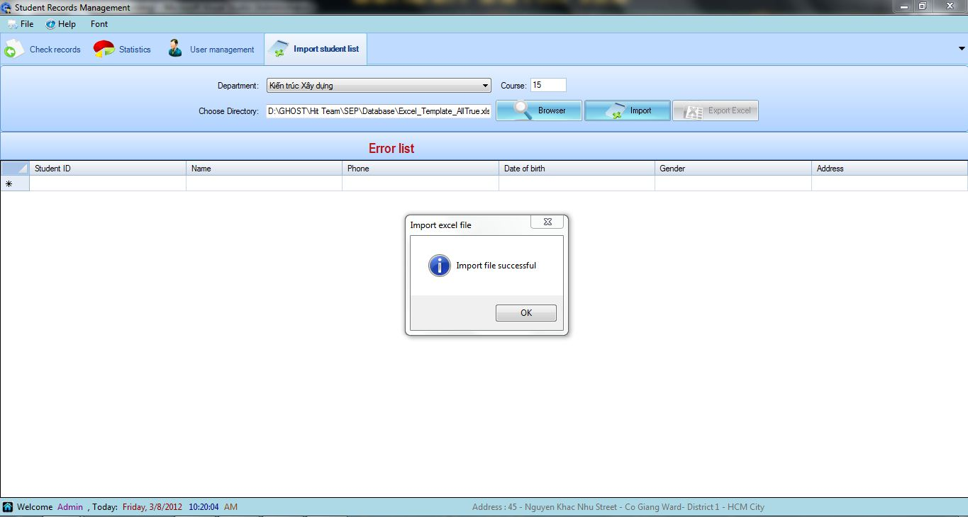

|  |  |
| --- | --- |
| Fields and Buttons | Rule |
| Course | Must to fill this text fields in number |
| Browse | Choose Excel file that have the right template, both xlsx and xls are allowed. |
| Export button | If the import excel file process has errors, the program will list rows of error information. So that user can choose Export Button to have the list of error information by Excel. |

If there is any wrong with the information, the program will list rows of error and not import them to the database. There will be an Error Message to notice you

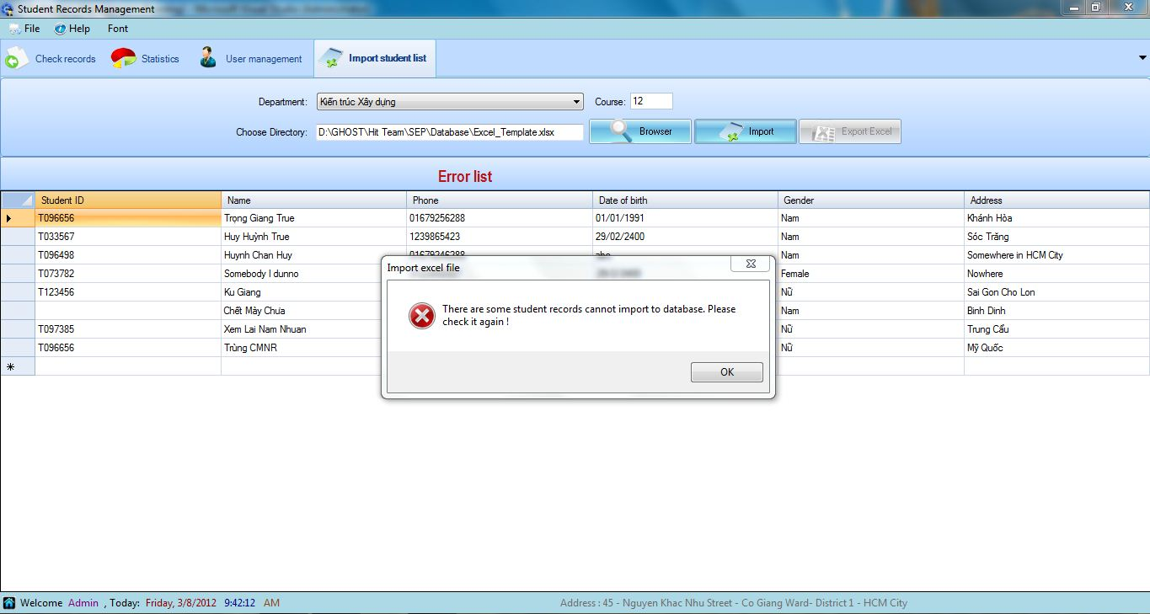

## Update Student Record and Print it

### Search Student Record

Student Records Management provides the ability to search for existing users’ account(s). When a search is performed, all records that meet the search criteria are returned in the Search Results section on the Search Accounts screen.

Depending on the user’s roles and privileges, the following options appear on the Search Accounts screen:

* For the Received Student Record Officer can only search their students who is learning in their department

The following search parameters can be entered, selected or checked to search for an account(s):

* Student ID

### Update Student Record

1. To edit the student information, user check to the combo box for which information student have commit to the Received Record Officer

2. Click the Print button to save the changes. The program will also show Print Record interface

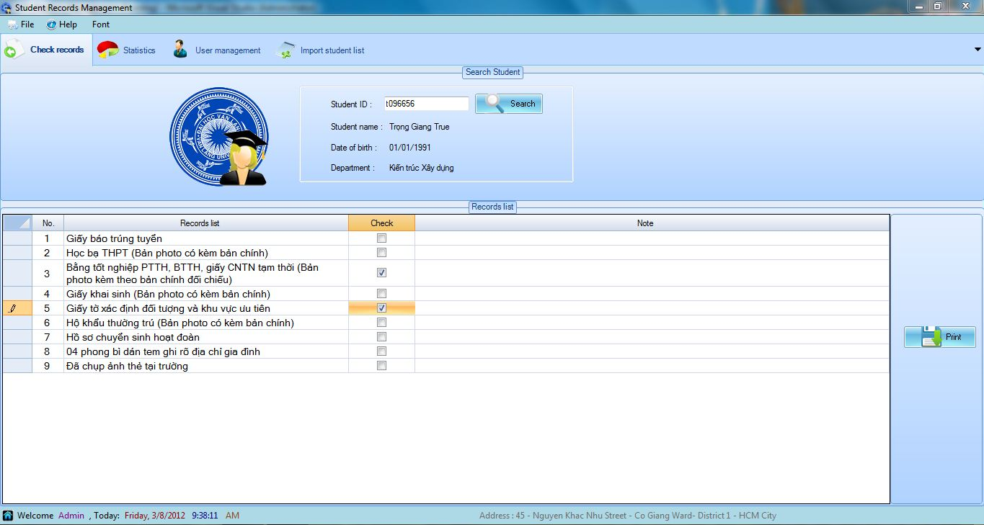

You can print directly by click the printer icon or you can also export the receipt into three types of file: Excel, Word, Pdf. And then save it wherever you want.

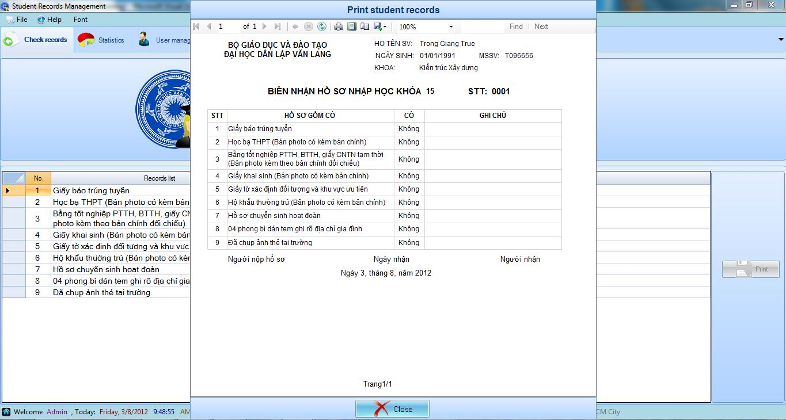

## Statistics

Student Records Management provides the ability to search for analysis statistics how many record have been received a day. Depending on the user’s roles and privileges, the following options appear on the Search Accounts screen:

* For the Received Student Record Officer and The Faculty Monitor: Statistic their department in overview. In addition, They also can have detailed statistics for 3 days to compare between Faculty and School

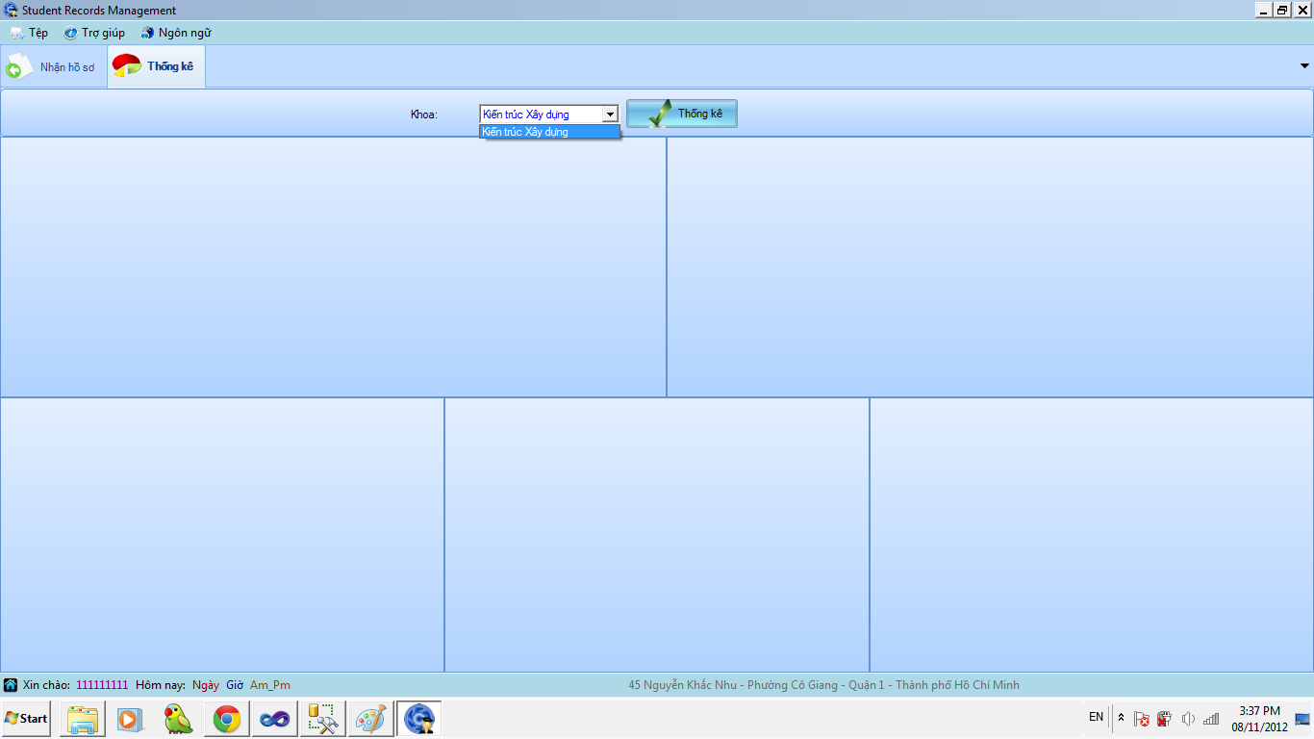

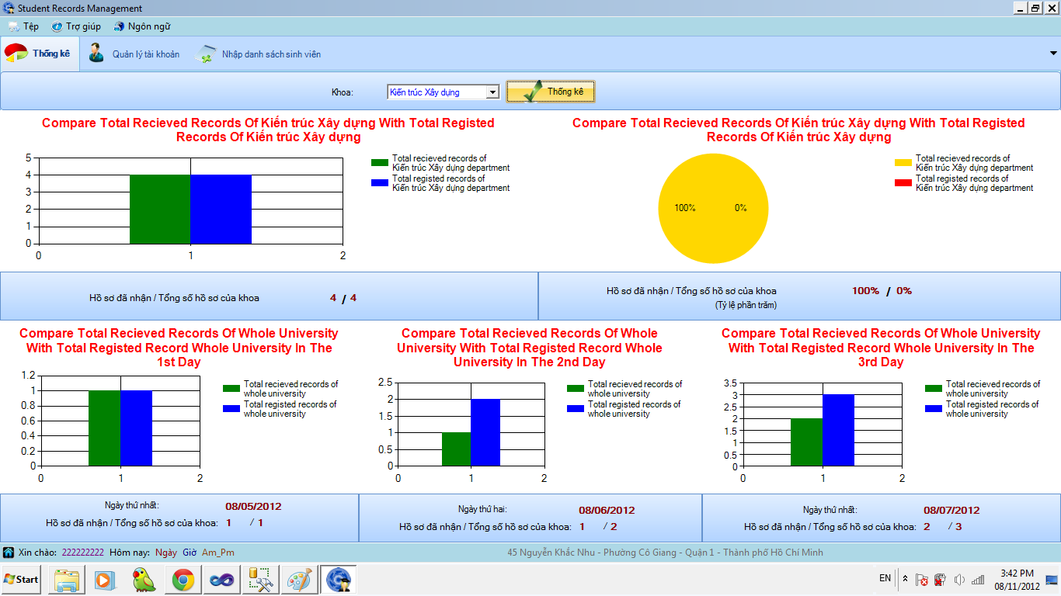

* High level account (not include admin, the Received Student Record Officer and The Faculty Monitor) can statistic (overview and details for 3 days) and all the department (overview and details for 3 days).
  + Statistic by Department

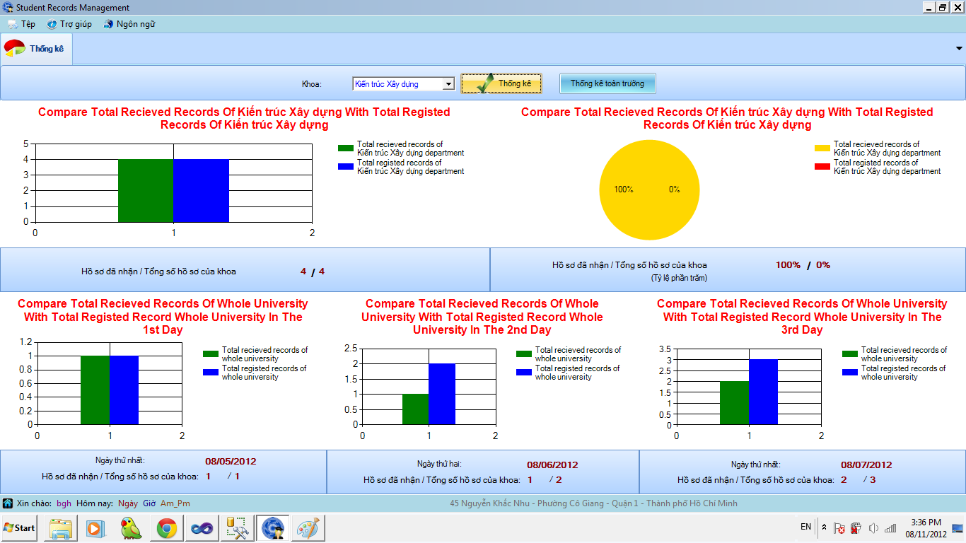

* + Statistic by the whole University

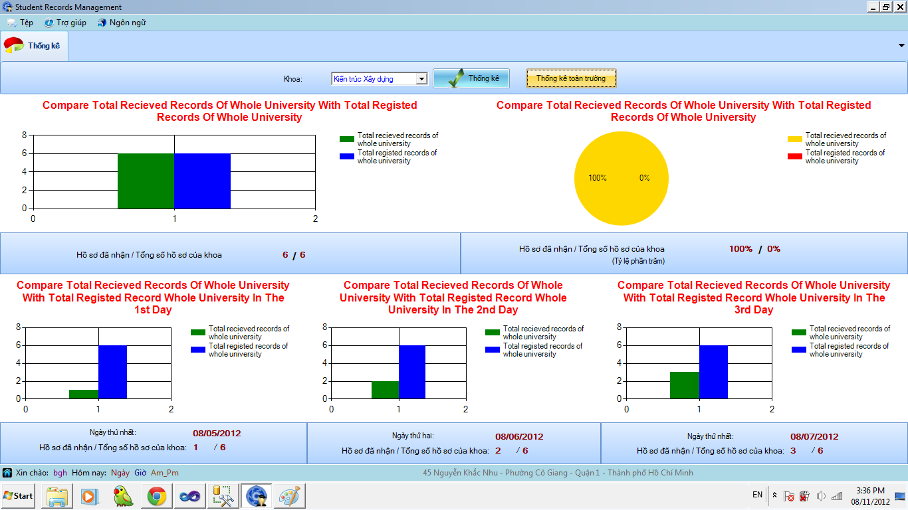

## Create New User Account

To create a new account, click the Create New Account button on the Search Accounts screen.

The system displays the Create a New Account screen. Depending on user’s privileges creating the account, the following User Type appears on the Create New Account screen:

* For The Faculty Monitor, they can only select Received Student Record Officer.
* For the Administrator, they can select all of user types.
  + When they choose these four types of account: Administrator, The Training Department Officer, The Human Resource Department Officer, The Management Committee, they only can select “High level Account” on Department label
  + When they choose these two types of account: Faculty Monitor, Received Student Record Officer, they can select one of fourteen department of the university

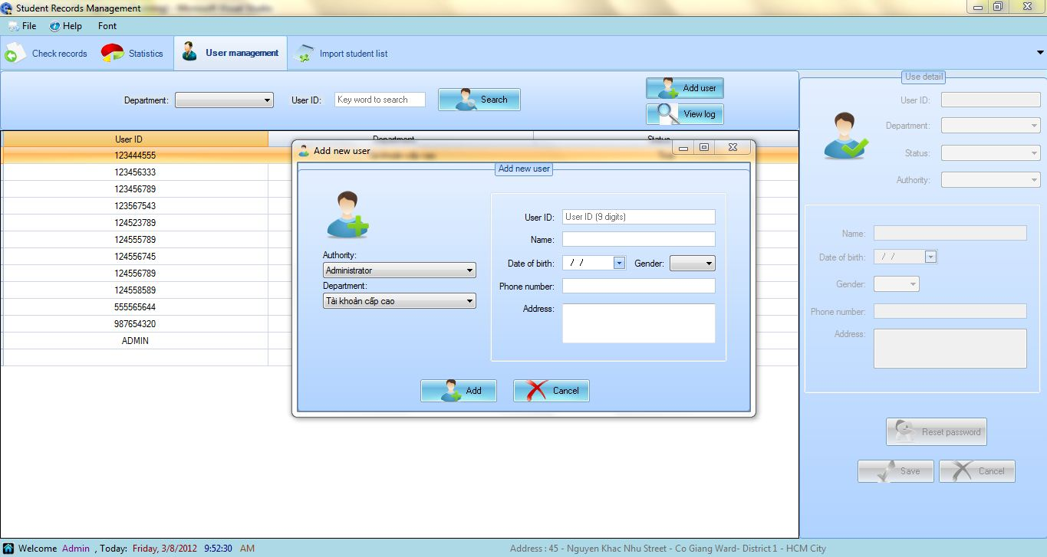

|  |  |
| --- | --- |
| Fields and Buttons | Rule |
| User ID | The program use the Identify Number |
| Name | Must have a minimum of one (1) characters, maximum of twenty (50) characters. |
| Date of birth | Must before the present day |
| Phone Number | Must have a minimum of one (1) characters, maximum of twenty (15) characters. |
| Address | Must have a minimum of one (1) characters, maximum of twenty (200) characters. |

***Notice:*** After creating, password of that user will be the same as “Name”

## Search User Account

Account Management provides the ability to search for existing users’ account(s). When a search is performed, all records that meet the search criteria are returned in the Search Results section on the Search Accounts screen.

Depending on the user’s roles and privileges, the following options appear on the Search Accounts screen:

* For The Faculty Monitor, they can’t see the Department combo box
* For the Administrator, they can select types of department.

The following search parameters can be entered, selected or checked to search for an account(s):

* Department: List of Department that can be searched on
* User ID: User login identification name

## Reset Password

Account Management provides the ability to reset a user’s password. The password can be reset to a system-generated password: *vanlang* when a user forgets their password and cannot log onto the system or when the maximum number of logins has passed and users are locked out of an account. To reset the password, select the Reset Password button.

## Change Status

In the situation that the user has no more authority to access the system, you can change their status form True to Fault. Finally, you choose the Save button to save their status

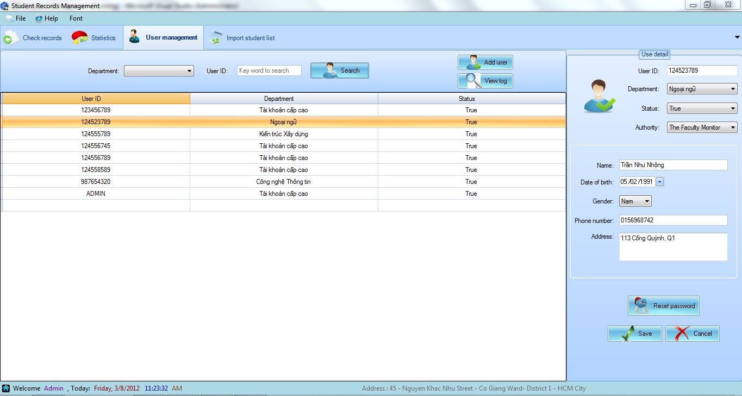

## View Log

User Management provides the ability to search for view log. When a search is performed, all records that meet the search criteria are returned in the Search Results section on the View Log screen.

The following search parameters can be entered, selected or checked to search for an account(s):

* From Date To Date: Choose date
* User ID: User login identification name

Then choose View after enter all below

To show all action, choose “Show All” then

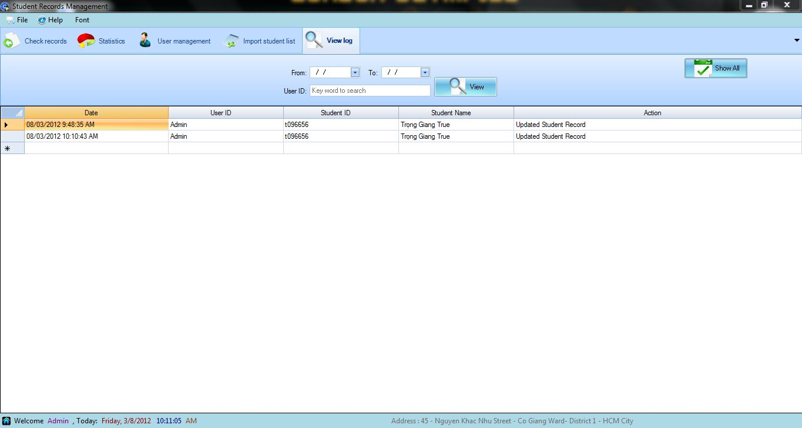

## Change Password

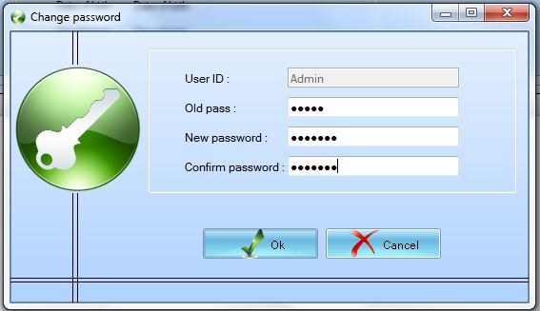

|  |  |
| --- | --- |
| Fields and Buttons | Rule |
| User name | You don’t have to fill it. We auto it already |
| Old Password |  |
| New Password and Confirm Password | Must have a minimum of one (1) characters, maximum of twenty (32) characters. |

## Hide To Tray

When you have done with the program, you can hide it as an icon in the task bar

Step 1: Choose File

Step 2: Choose Hide to Tray

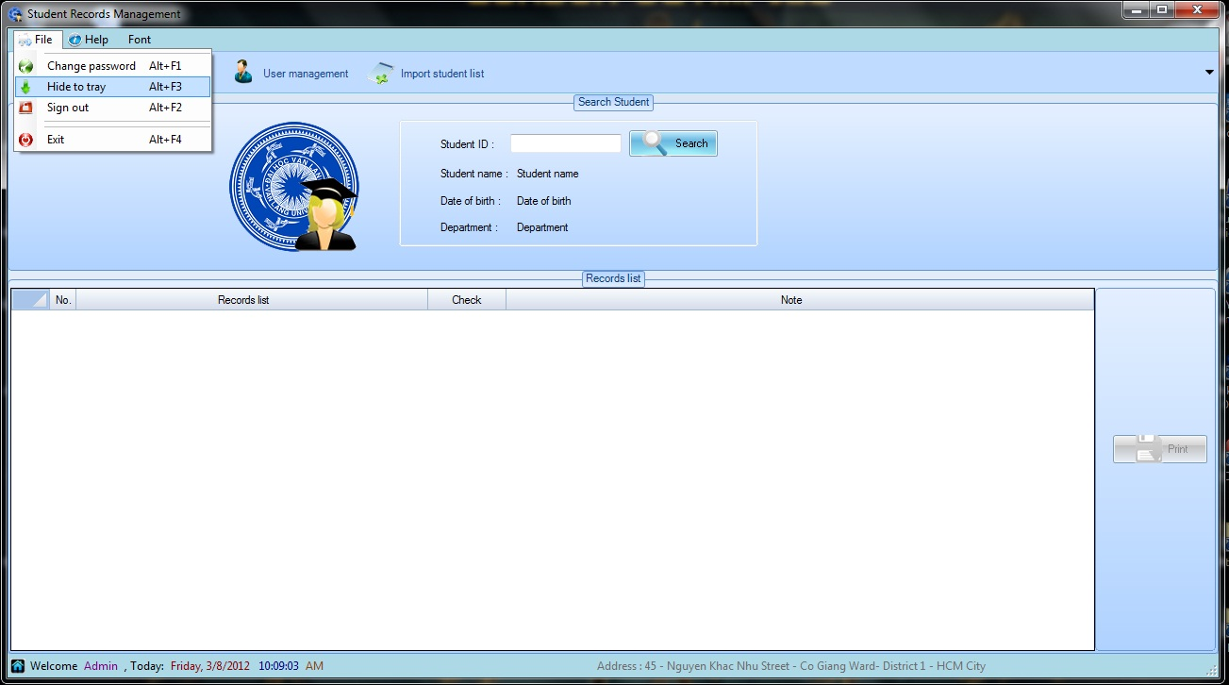



## Logout

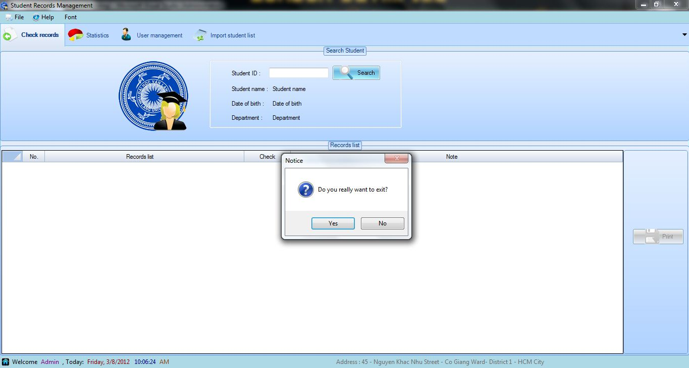

# SECTION 2: WEB APPLICATION

This web form is only used for the high level account (not include admin, the Received Student Record Officer and The Faculty Monitor) can statistic (overview and details for 3 days) and all the department (overview and details for 3 days).

## Login

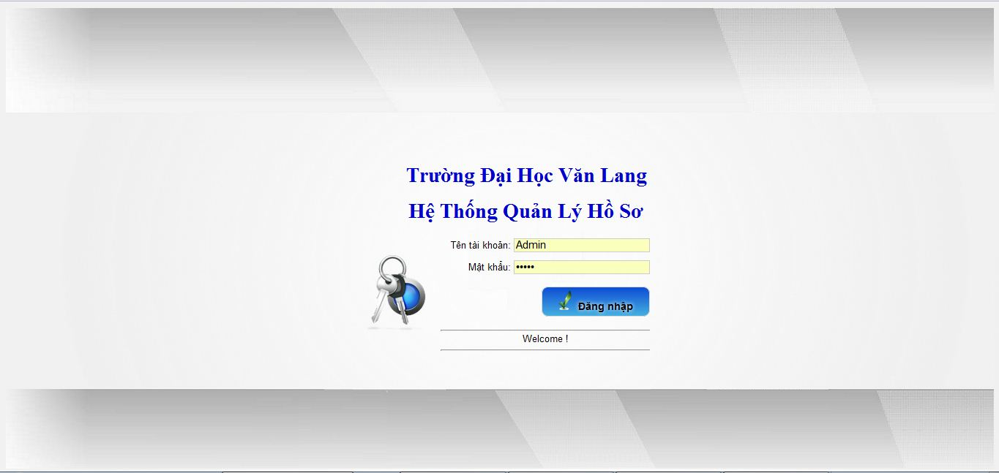

## Statistic by the whole University

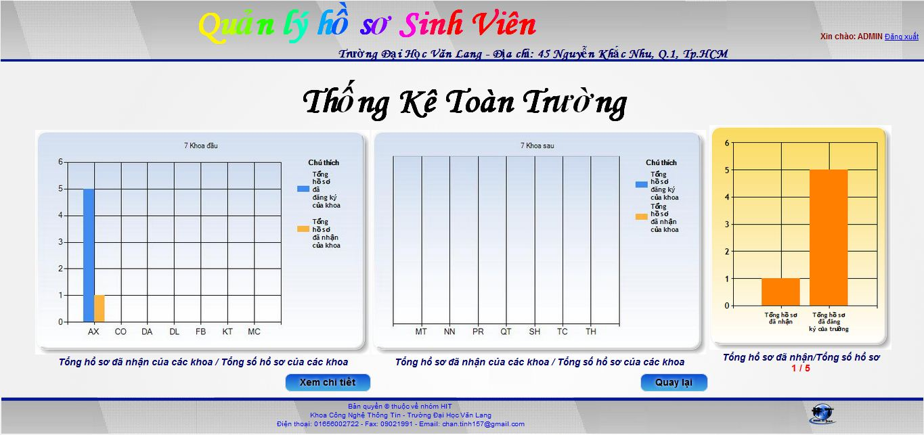

**In Detail**

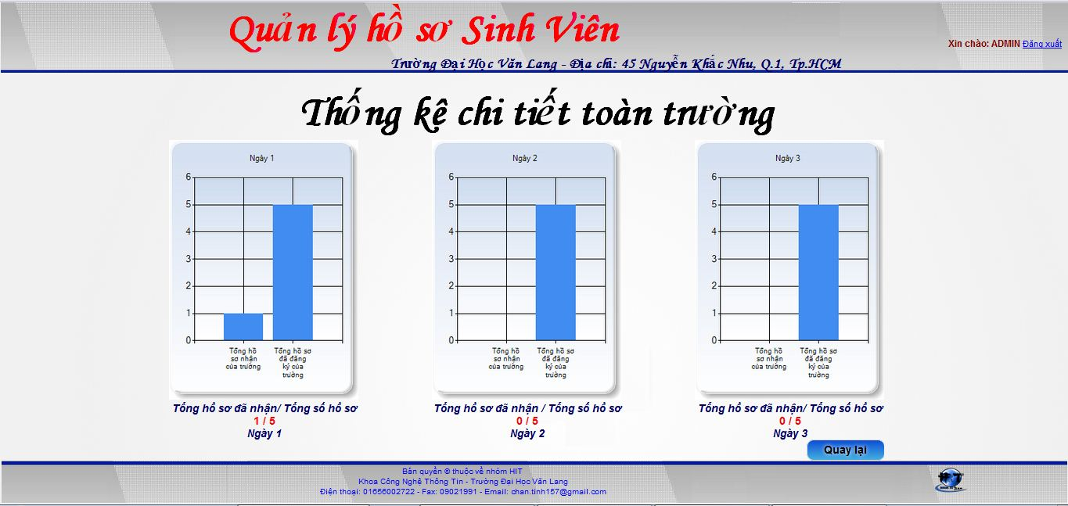

## Statistic by Department

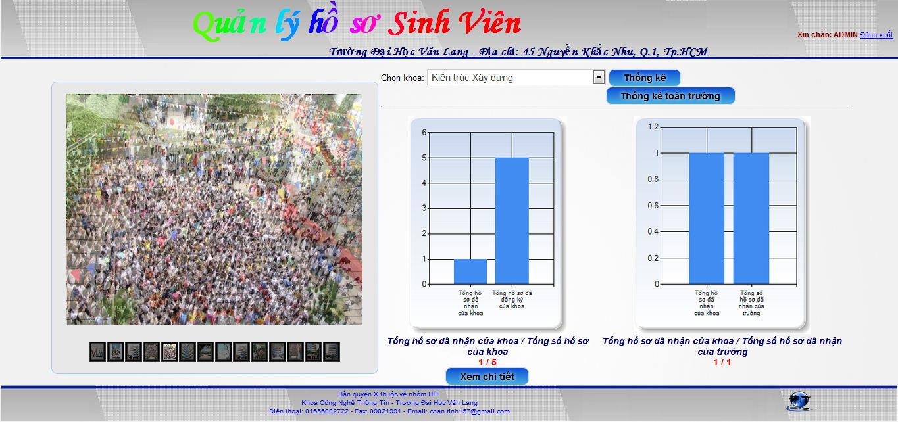

**In Detail**

